Vulcan Activity Tracker
Compile Instructions

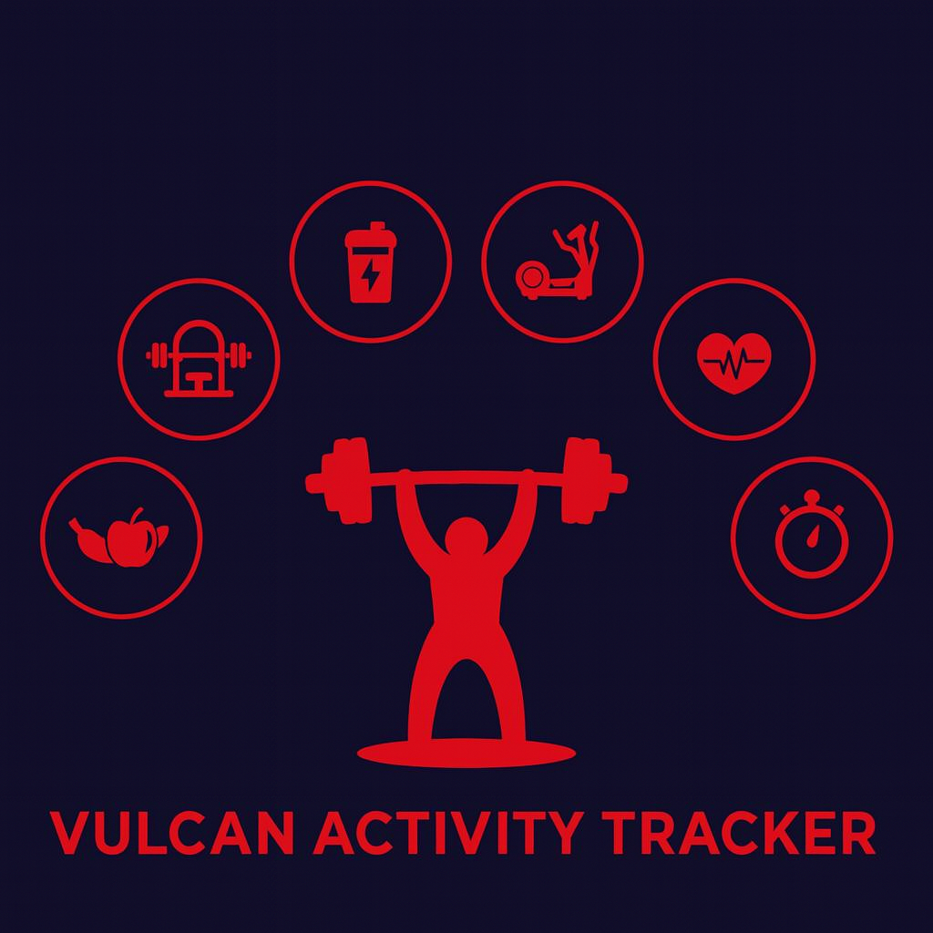

Team Members:
Margo Bonal
John Gerega
Luke Ruffing

Professor: Dr. Weifeng Chen

Course: CMSC-4920-Senior Project II
School: Pennsylvania Western University

Developer Instructions:
The following developer technical instructions are for Windows 10/11 operating systems. To build and run the Vulcan Activity Tracker codebase locally from developers’ machine (laptop or PC). Source code solution will be submitted upon senior project deadline. This will include a ZIP folder of the project code base, named Vulcan Activity Tracker.

Step 1:
The first step will be to download the Vulcan Activity Tracker folder from D2L. Move the folder to a location on the computer where it is easily accessible and isolated from other software that may interact or cause disturbance. Our development team recommends either the Documents folder or an empty OneDrive Folder. Once the file is placed, unzip the folder or extract the file contents. The files are then prepared for the next step.
If, in any case, the ZIP file is inaccessible, the folder can be found online at our group's GitHub repository: https://github.com/jjdeuce06/VulcanActivityTracker
Here, the Vulcan Activity Tracker can be downloaded manually, or can be cloned/ssh directly into the code editor.

Step 2:
Developers must prepare their computers to build the Vulcan Activity Tracker codebase. Since containerized, Docker, an external containerization software, must be installed. Navigate to the site: https://www.docker.com/ and proceed to download Docker Desktop. Select your proper operating system, in this case, Windows.
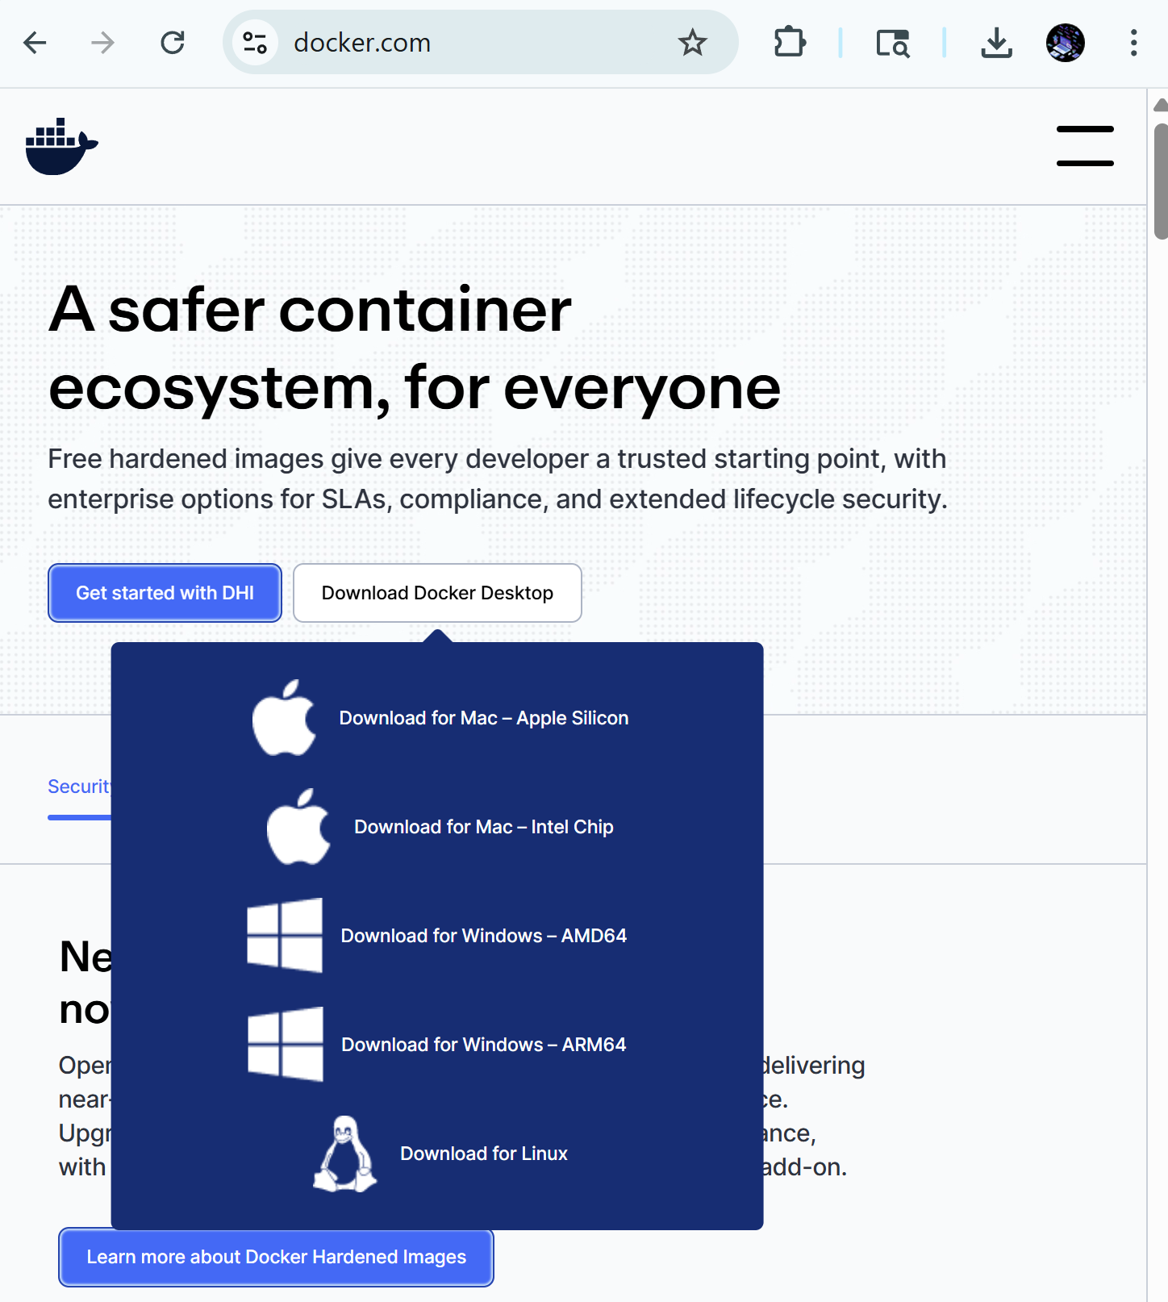Figure 1: Docker Desktop Download
Proceed through the installation process. The Docker Installation Wizard will provide additional steps to ensure proper installation. After installation, the developer will be prompted to restart the computer. When the system is rebooted, Docker Desktop will be ready to use. Installation success can be verified in the terminal with the command: docker --version, with expected output as Docker version 24.0.x followed by a build number.

Step 3:
Now navigate back to the folder where the Vulcan Activity Tracker folder is stored. In either a code editor like Visual Studio Code, or right from the command prompt. The app can only be run if the environment is in the Source Code File. The project will be submitted in a ZIP folder(VulcanActivityTracker-ZipFolder), it will be required to open the Source code folder within. This is a very crucial step. Move through files in the terminal with the cd command along with the folder name, i.e., cd SourceCode/
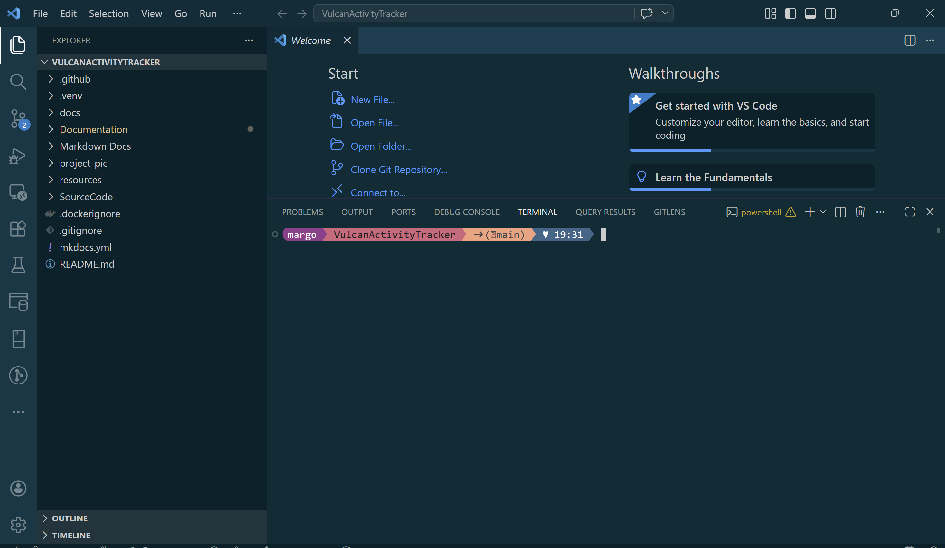
Figure 2: Vulcan Activity Tracker Open in code editor
Within the source code file, all files to properly build the project will be accessible. This can be verified by windows terminal command ls
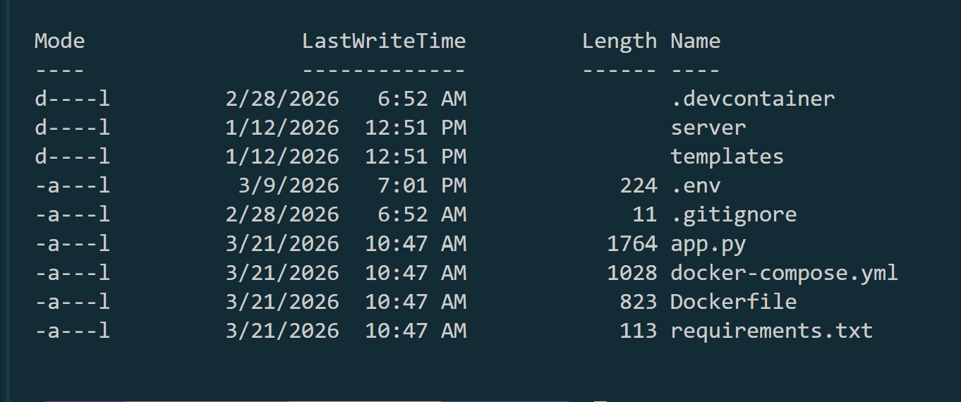
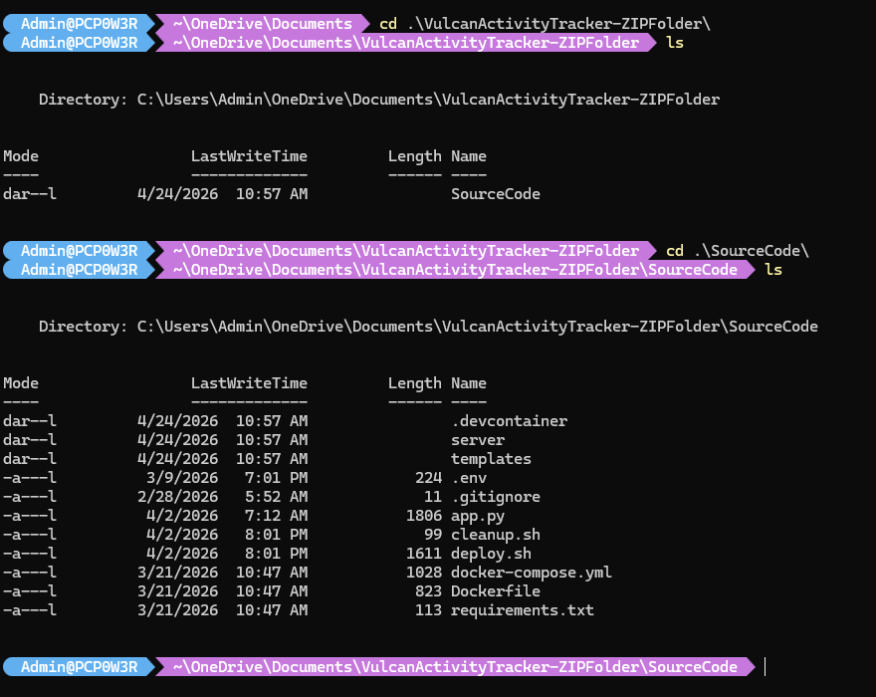
Figure 3: Source code folder contents

Step 4:
The fourth developer technical step will be to run the docker container. Since our application is structured with group collaboration in mind, containerization allows the app itself to download and install all dependencies to function. Docker desktop application MUST be open in background for engine to start running. In the SourceCode Directory in the terminal, enter the command docker compose up --build
This will initiate the docker container to build the database, app server, and online website. Docker will move through the requirements.txt file automatically and build all resources and dependencies that the app needs. Once the app is built, the terminal will show messages that the database tables have been initialized and are prepared for platform use. Navigate in the browser to localhost:6455 to view the app built locally. If for any reason the docker container failes to build, run the command docker compose up --build again to fix dependecy problems.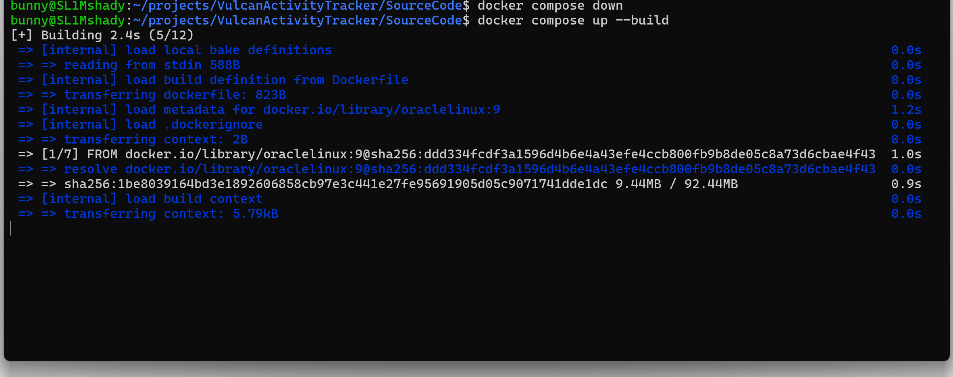
Figure 4: Docker initializing build
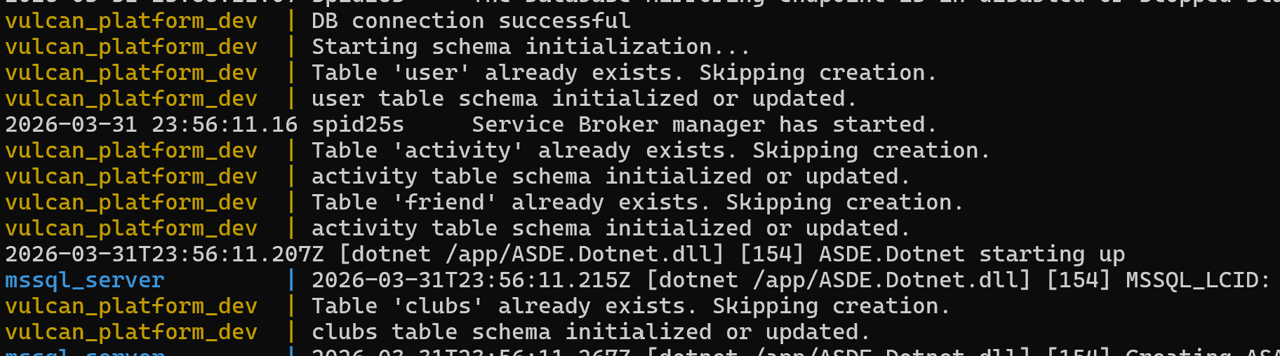
Figure 5: Database tables built, signals app is ready to access
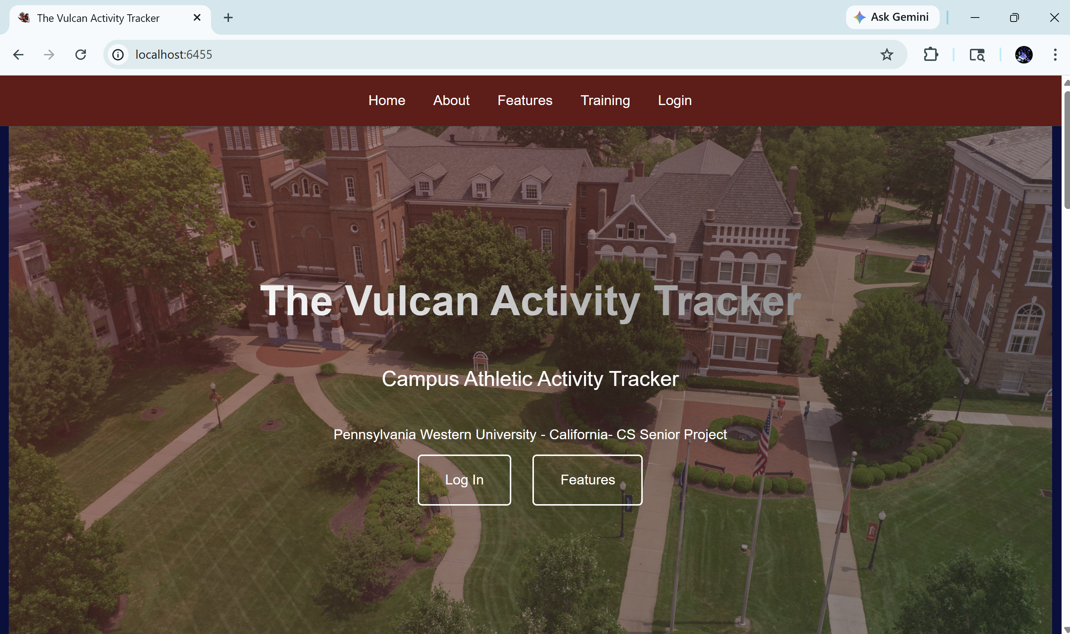
Figure 6: App is accessed by localhost:6455 in browser
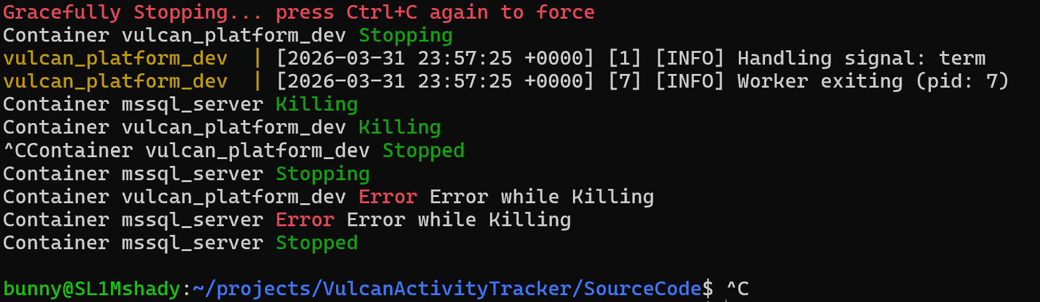
Figure 7: App is stopped locally by Ctrl-C key combination
This concludes the developer instructions portion of this document. Please reach out to the development team with any questions or errors regarding the local building process.

